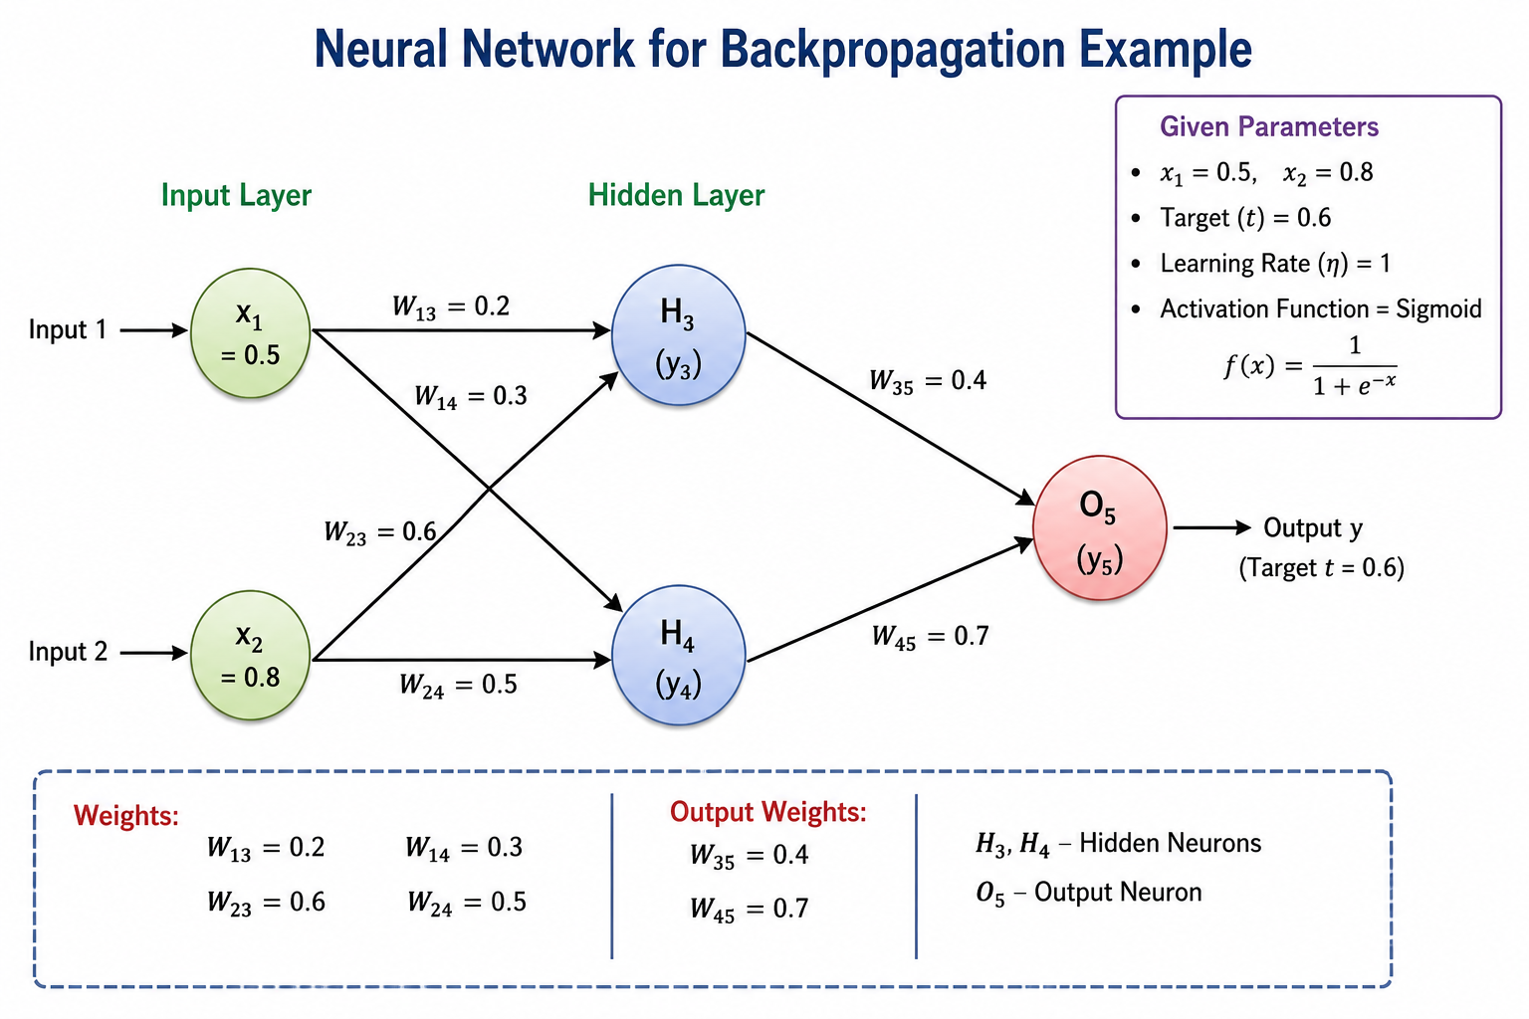

Given
Inputs
- $x_{1}=0.5$
- $x_{2}=0.8$
Hidden Layer Weights
- $W_{13}=0.2$
- $W_{23}=0.6$
- $W_{14}=0.3$
- $W_{24}=0.5$
Output Layer Weights
- $W_{35}=0.4$
- $W_{45}=0.7$
Target Output
$$t=0.6$$
Learning Rate
$$η=1$$

Step 1: Forward Pass
Calculate Hidden Neuron H₃
$$net_{3}=(x_{1}W_{13})+(x_{2}W_{23}) \\ =(0.5)(0.2)+(0.8)(0.6) \\ =0.1+0.48 \\ =0.58$$
Apply sigmoid:
$$y_{3}=\frac{1}{1+e^{-0.58}} \\ y_{3}=0.6411$$

Calculate Hidden Neuron H₄
$$net_{4}=(x_{1}W_{14})+(x_{2}W_{24}) \\ =(0.5)(0.3)+(0.8)(0.5) \\ =0.15+0.40 \\ =0.55$$
Apply sigmoid:
$$y_{4}=\frac{1}{1+e^{-0.55}} \\ y_{4}=0.6341$$

Calculate Output Neuron O₅
$$net_{5}=(y_{3}W_{35})+(y_{4}W_{45}) \\ =(0.6411)(0.4)+(0.6341)(0.7) \\ =0.2564+0.4439 \\ =0.7003$$
Apply sigmoid:
$$y_{5}=\frac{1}{1+e^{-0.7003}} \\ y_{5}=0.6683$$

Step 2: Calculate Error
$$Error=t-y_{5} \\ =0.6-0.6683 \\ =-0.0683$$

Step 3: Calculate Output Delta
$$δ_{5}=(t-y_{5}) y_{5}(1-y_{5}) \\ =(-0.0683)(0.6683)(0.3317) \\ δ_{5}=-0.0151$$

Step 4: Update Output Weights
Update W₃₅
$$W_{35}^{new}=W_{35}+η(δ_{5})y_{3} \\ =0.4+(-0.0151)(0.6411) \\ =0.3903$$

Update W₄₅
$$W_{45}^{new}=W_{45}+η(δ_{5})y_{4} \\ =0.7+(-0.0151)(0.6341) \\ =0.6904$$

Step 5: Hidden Layer Delta
Hidden Neuron H₃
$$δ_{3}=y_{3}(1-y_{3})(δ_{5}W_{35}) \\ =(0.6411)(0.3589)(-0.0151)(0.4) \\ =-0.00139$$

Hidden Neuron H₄
$$δ_{4}=y_{4}(1-y_{4})(δ_{5}W_{45}) \\ =(0.6341)(0.3659)(-0.0151)(0.7) \\ =-0.00245$$

Step 6: Update Hidden Layer Weights
W₁₃
$$W_{13}^{new}=0.2+(-0.00139)(0.5) \\ =0.1993$$

W₂₃
$$W_{23}^{new}=0.6+(-0.00139)(0.8) \\ =0.5989$$

W₁₄
$$W_{14}^{new}=0.3+(-0.00245)(0.5) \\ =0.2988$$

W₂₄
$$W_{24}^{new}=0.5+(-0.00245)(0.8) \\ =0.4980$$

Final Answer
Hidden Layer Outputs
- $y_{3}=0.6411$
- $y_{4}=0.6341$
Output Layer Output
- $y_{5}=0.6683$
Error
- $-0.0683$
Updated Output Weights
- $W_{35}=0.3903$
- $W_{45}=0.6904$
Updated Hidden Weights
- $W_{13}=0.1993$
- $W_{23}=0.5989$
- $W_{14}=0.2988$
- $W_{24}=0.4980$

